KANTHA Tote Bag (Finished size approx. 13” w x 14 ½”)
Description: This tote bag is created from two (approximately) 27” long panels which have been pieced together, then seamed lengthwise. This seamed piece is folded in half lengthwise to create the front and back of the tote. One panel includes and incorporated pocket; in this pattern it is called the “right” side.
Supplies
- KANTHA fat quarters
- ½ yd lining fabric
- 1-1 ½ yds woven strapping for handles (depends on your desired length)
- Thread to match

*Read all directions before you begin
*Use ½ inch seam allowances unless otherwise stated

- Creating the pocket unit
- Cut a 7 ½” x 9 ½” section from any one KANTHA fat quarter.
- Cut the same size from the lining fabric.
- Sew the pocket to the lining right sides together on the shorter edge. Use a ¼ inch seam for this.
- Turn the unit right sides out and press.
- Top stitch ¼ inch from the seamed edge. Set aside for now.

- Creating the pocket(right) side of the bag
- Cut a 7 ½” x 15 1/2” section from any fat quarter.
- Cut a 7 ½” x 12 1/2” section from any fat quarter.
- With right sides together place the pocket unit in step A on top of the bottom of the 7 ½ x 12 ½ section. (see photo)
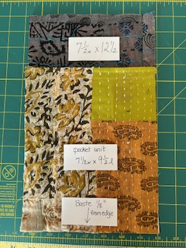

- Baste the pocket at the bottom of this section about 1/8” from the edge.
- Using a ½ inch seam allowance, and with right sides together, sew the pocket unit to the 7 ½ x 15 ½ inch section on the shorter side. Backstitch. Press the seam away from the pocket. (see photo)
- Measure the length of this unit and record it here. _______________inches long
- It should be approximately 27 inches long.

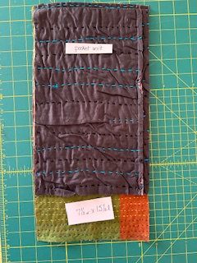
- Creating the LEFT side of the bag
- Cut a 7 ½ x 8 ½ section from any fat quarter.
- Cut a 7 ½ x 21 inch section from any fat quarter. This will be trimmed to measure later.
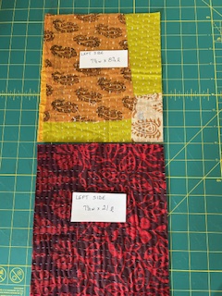
- Using a ¼ inch seam allowance and with right sides together, sew the two sections on the shorter side to create a longer section. Press the seam allowance in either direction.
- Trim the length of this unit to the measurement that you recorded in step B6.

- Sewing the RIGHT and LEFT sections together
- Sew the two units, RIGHT and LEFT, together down the middle seam using a ½ inch seam allowance.
- Press the seam in whichever direction it wants to fall the easiest.
- Fold the bag in half, right sides together, and sew the side seams using a ½ inch seam allowance.
- Press these seams open.
- Turn the bag right side out.
- Adding the straps
- Cut the woven strapping to the desired length. You will need two.
- Pin the straps to the bag at the top edge 3 inches from each side seam. (see photo)
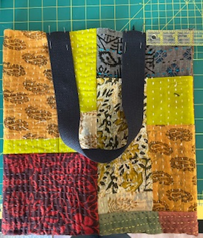
- Baste the straps 1/8 inch from the top edge using a larger machine stitch. Set aside.
- Adding the top edge of the bag
- Cut a strip 5” w x 26” l from the fat quarters. You will have to piece this in order to get the length you need.
- Using a ½ inch seam allowance sew together the short ends to create a closed circle. Press the seams open.
- With right sides together, place the unit on the top of the bag. Align the seam with one of the side seams on the bag. Pin or clip around the top. (see photo)
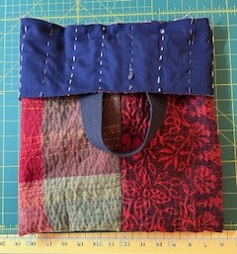
- Using a ½ inch seam allowance, stitch around the top edge catching the straps in the seam. Backstitch at the straps to secure them well.
- Turn the bag right side out. Press the piece you just sewed toward the center of the bag.
- Topstitch ¼ ich from the top of the bag.
- Creating the bag lining
- Cut the lining fabric 13 ½ w x 28” l.
- Fold lining in half right sides together to 13 ½” w x 14 l.
- Using a ¼ seam allowance, sew each side seam. Back stitch at both ends.
- Turn lining right side out.
- Inserting the lining and finishing the bag
- With wrong sides together, place the bag inside the lining. Push the bag bottom down into the lining. It will be smaller than the bag. (see photo)

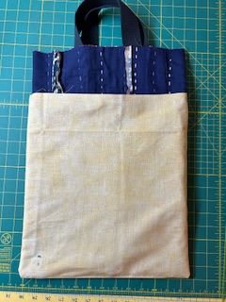
- Fold the top edge of the bag down over the lining.
- Turn the edge of the bag under approximately 1 inch and pin. This will enclose the lining. (see photo)
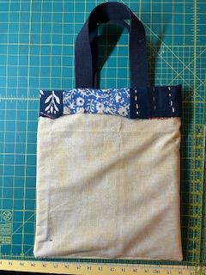
- Hand stitch the top of the bag to the lining.
- Turn the bag right side out.
- Enjoy your bag!
